Alg 3 Summer Name: ____________________________

______________ _____________

WS Assessment

Target 6:

Exponential function

**I can:**

* Use rules of exponential to manipulate given expression
* Understand Growth vs Decay of exponential function. Find its domain, range and End behavior.
* **Unit 3: Logarithms & Exponentials**
* **C**[**CSS.MATH.CONTENT.HSF.LE.A.4**](http://www.corestandards.org/Math/Content/HSF/LE/A/4/): For exponential models, express as a logarithm the solution to *abct* = *d* where *a*, *c*, and *d*are numbers and the base *b* is 2, 10, or *e*; evaluate the logarithm using technology.
* [**CCSS.MATH.CONTENT.HSF.IF.C.7.E**](http://www.corestandards.org/Math/Content/HSF/IF/C/7/e/): Graph exponential and logarithmic functions, showing intercepts and end behavior
* **C** [**CSS.MATH.CONTENT.HSF.IF.B.4**](http://www.corestandards.org/Math/Content/HSF/IF/B/4/): For a function that models a relationship between two quantities, interpret key features of graphs and tables in terms of the quantities, and sketch graphs showing key features given a verbal description of the relationship. *Key features include: intercepts; intervals where the function is increasing, decreasing, positive, or negative; relative maximums and minimums; symmetries; end behavior; and periodicity*.*
* [**CCSS.MATH.CONTENT.HSF.IF.C.8.B**](http://www.corestandards.org/Math/Content/HSF/IF/C/8/b/): Use the properties of exponents to interpret expressions for exponential functions. For example, identify percent rate of change in functions such as y = (1.02)ᵗ, y = (0.97)ᵗ, y = (1.01)12ᵗ, y = (1.2)ᵗ/10, and classify them as representing exponential growth or decay.
* [**CCSS.MATH.CONTENT.HSF.BF.A.1**](http://www.corestandards.org/Math/Content/HSF/BF/A/1/): Write a function that describes a relationship between two quantities.*
* [**CCSS.MATH.CONTENT.HSF.BF.A.1.A**](http://www.corestandards.org/Math/Content/HSF/BF/A/1/a/): Determine an explicit expression, a recursive process, or steps for calculation from a context.
* [**CCSS.MATH.CONTENT.HSF.BF.A.1.B**](http://www.corestandards.org/Math/Content/HSF/BF/A/1/b/): Combine standard function types using arithmetic operations. *For example, build a function that models the temperature of a cooling body by adding a constant function to a decaying exponential, and relate these functions to the model*.
* [**CCSS.MATH.CONTENT.HSA.SSE.A.1.B**](http://www.corestandards.org/Math/Content/HSA/SSE/A/1/b/): Interpret complicated expressions by viewing one or more of their parts as a single entity. *For example, interpret P(1+r)n as the product of P and a factor not depending on P*.

Exponential Properties

Product rule (am)(an) = a m + n example x3 x 4 = x 3 + 4 = x7

Quotient rule $\frac{a^{m}}{a^{n}}=a^{m-n}$ $\frac{x^{7}}{x^{2}}=x^{7-2}=x^{5}$

Power rule (am)n = amn (x3)2 = x (3)(2) = x6

Zero power a0 = 1 Any number power zero = 1 2340 = 1

Negative power $a^{-n}=\frac{1}{a^{n}}$ $x^{-2}=\frac{1}{x^{2}}$

Rational power $a^{\frac{m}{n}}=\sqrt[n]{a^{m}}$ $x^{\frac{2}{3}}=\sqrt[3]{x^{2}}$

Using the above rules do the following and write as positive power

(x2)(x3) = ? x2x-3 = x-2x-5 = 2x2x5 =

(x3)4 = (x –3)4 = (x –3) – 5 = (x –4)0 =

2(x –3)2 = (2x –3)2 = (2x 3)– 2 = (.25x 4)– 2 =

Simplify

${\left(\frac{x^{2}x^{-3}}{x^{-4}}\right)}^{\frac{2}{3}}$ = ${\left(\frac{x^{-5}x^{-7}}{x^{3}}\right)}^{\frac{4}{7}}$ =

${\left(\frac{27x^{-3}}{x^{-4}x^{3}}\right)}^{\frac{1}{3}}$ = ${\left(\frac{3125x^{-7}}{x^{3}x^{-5}}\right)}^{\frac{1}{5}}$ =

Multiplier

The base number b in the exponential function y = abx is also called a multiplier. When there is a rate (percentage) involve, it is written as y = a(1+r)x

For example, the multiplier for an increase of 7% is b = 1 + 0.07 = 1.07 and the multiplier for a decrease of 7% is 1 – 0.07 = 0.93

Write the multiplier for the following situations

a 25% increase → multiplier =? ___________ 3% increase → __________

a decrease of 18% → 25% decrease →

an increase of 39% → 13% decrease →

a decrease of 9.4% → 2.08% increase →

State the multiplier b and the increasing or decreasing percentage r of the following situations

y = 1.2x → b =? r =? Increase or Decrease?

y = 5(0.74)x → y = 2x →

y = 3(0.5)x → y = -2(1.015)x →

y = -(0.04)x → y = 2(3x) →

y = 3(.95x) → y = -2x →

Use Graphing calculator, sketch the following. Identify the function’s growth or decay. State its domain, range, and End behavior

|  |  |
| --- | --- |
| y = 0.5(2)x  Image result for graph template word | y = 2(0.5)x  Image result for graph template word |
| y = -0.5(2)x  Image result for graph template word | y = -2(0.5)x  Image result for graph template word |

Identify the function’s growth or decay, state its domain, range, and End behavior for the following.

|  |  |
| --- | --- |
| Without graphing identify the exponential functions:  y = 0.3(3)x  y = -0.3(3)x  y = 3(0.3)x  y = -3(0.3)x |  |

Identify this exponential graph and show me for stamp:

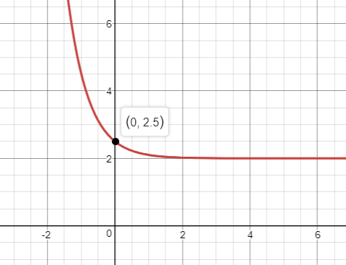

  Solve for x

2x+3 = 2x 3x+1 = 32x 22x+1 = 8 3x-2 = 27

2x-3 = 22x 3x-1 = 32x+5 22x+1 = 16 3x-2 = 81

9x = 32 9x = 33 9x = 38 9x = 729

9x = 35 8x = 23 25x = 58 25x = 5-2

27x – 4 = 9x – 3 256x + 4 = 64x – 2

**Assessment Target 6**

**I can…** use exponential rules, identify function’s behavior and solve equations

1. Simplify the following, only using positive exponents

$\frac{{(2x^{2}x^{-3})}^{-5}}{10x^{-6}}$ ${\left(\frac{3125x^{-8}}{x^{2}x^{-4}}\right)}^{\frac{1}{5}}$ =

1. Identify this exponential (growth or decay, domain, range and End behavior) graph and show me for stamp

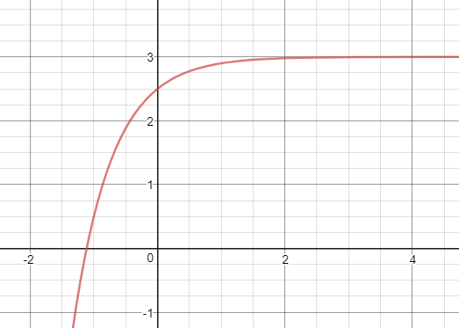

1. Solve the following exponential equation

243x – 1 = 272x

1. A culture of bacteria has an initial population of 48000 bacteria and doubles every 9 hours. Using the formula $P_{t}=P_{0}×2^{\frac{t}{d}}$  ​, where Pt ​ is the population after *t* hours, P0​ is the initial population, *t* is the time in hours and *d* is the doubling time, what is the population of bacteria in the culture after 10 hours, *to the nearest whole number*? (Ans 103686)